THE CIRCULATORY SYSTEM
Activity A36
The heart
The heart pumps blood around inside the body, blood carries oxygen and other things our bodies need to survive.
Blood is transported within blood vessels, the shape and size of these vary depending on where they are carrying blood to or from.
Some vessels take blood with oxygen in it to our organs that need it in order to work properly. Other blood vessels have the job of returning the blood to the lungs and heart after the oxygen has been used. The blood is then re oxygenated and the heart pumps it around the body again. This happens all the time without stopping, even when we are asleep.
Activity:
- Using the diagram below, make your own model of the way blood travels around the human body. You might also want to do some research and add other organs in to the diagram i.e stomach, kidneys, intestines. (Red represents the blood rich with oxygen and blue is the blood that is returning to lungs for reoxygenation.)
- You can choose and use materials you think will work well. Consider colour pens, wool or cut out paper etc.
- You can use the outline of the human body as the start of your creation.
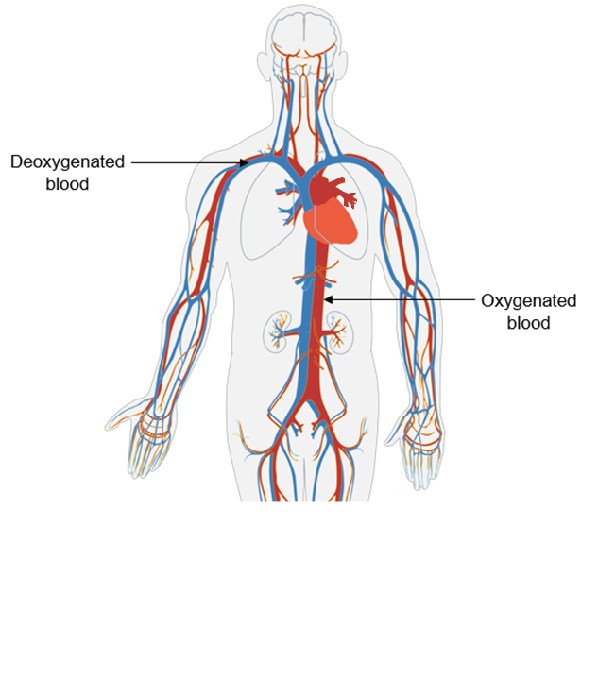
Heart
Pulmonary artery
Pulmonary vein

